*Changes and Additions for sprint 5 that needed testing:*

***In Faculty List (landing page)View****:*

*-Added a search bar for name or otterbein Id to sort and depopulate non-matching results.*

| Tests | Success/Fail |
| --- | --- |
| UpperCase first/last name | ✅ |
| LowerCase first/last name | ✅ |
| Multiple Numbers test | ✅ |
| Zero Heuristic | ✅ |

Example result: (Before)

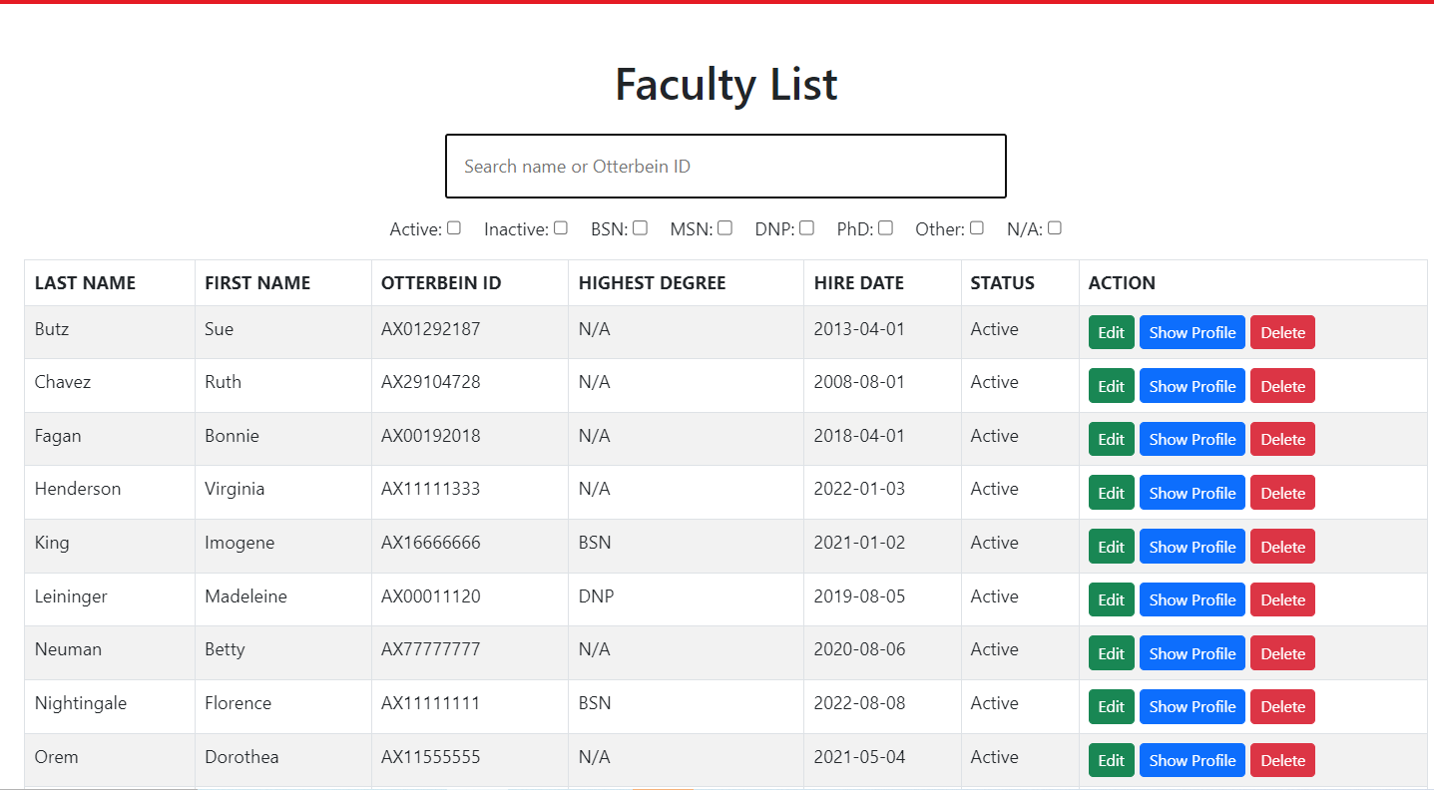

(After) 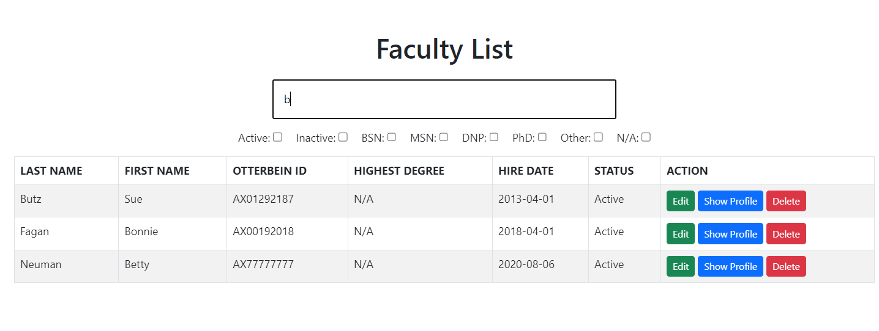

*-Added quick sort buttons for various degree types that depopulate all non-checked highest degrees.*

| Tests | Success/Fail | notes |
| --- | --- | --- |
| Active/InActive Button | ✅ | Filters the list currently populated unlike other filters filtering from the full list. |
| BSN | ✅ |  |
| MSN | ✅ |  |
| DNP | ✅ |  |
| PhD | ✅ |  |
| Other | ✅ | This case required additional code as it needs to compare degree types and check if there are no degree types of that kind. |
| N/A | ✅ | All members without degree are properly populated |
| Combinations | ✅ | There are some combinations that required different cases of code. |

Example Test Result: (before)

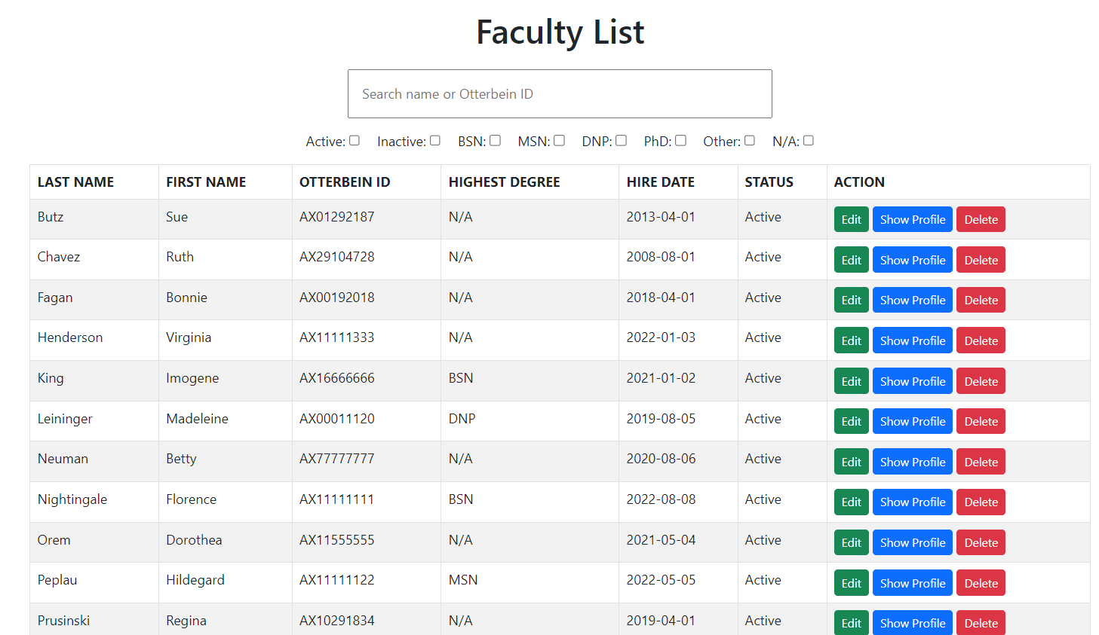

(after a test):

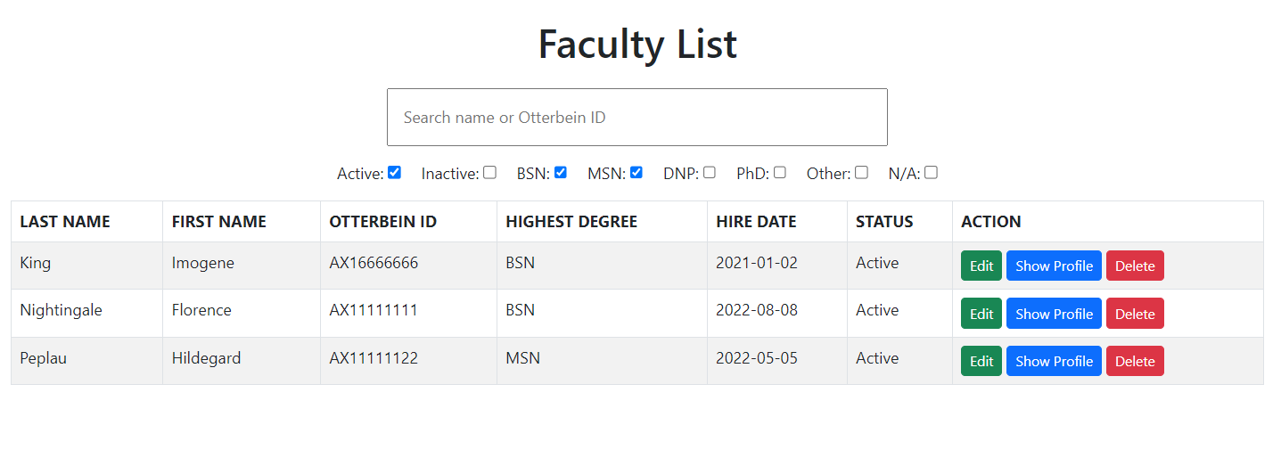

*-Changed Faculty List from populating only faculty with a degree on file to show all faculty with or without a degree.*

**TEST** : Check if all faculty regardless of degree are populated. ✅

***In Create a Faculty View:***

*-Added the ability to add degrees, documents, etc in the same page as embedded forms. When clicked the full form is expanded where the forms for other tables can be entered all in one location potentially making the upload process more intuitive.*

Notes from Test:

* Embedded forms cannot add to the faculty that you are currently adding. Which doesn’t make it the process more intuitive.(currently)
* The “Exemption letter needed?” is a check box. It is not immediately clear whether a check means an Exemption letter is needed. And if you should participate in the following form field if you don’t check the exemption letter needed box.
* Not clear that you can leave “when was the last semester taught and year taught fields” blank. Feels like there is no way to add faculty without previous teaching.

| Tests | Success/Fail | notes |
| --- | --- | --- |
| Create faculty with embedded forms | fail | Shows that I cannot add a faculty and something went wrong. (could be bad testing) |
| Degree embedded form | fail | Doesn’t route to the proper form. Says error cannot get /create-faculty |
| Document embedded form | fail | Doesn’t route to the proper form. Says error cannot get /create-faculty |
| Layout is properly rendered at appropriate locations | ✅ | Could still use more work on making embedded more intuitive still feels confusing. |

Notes for embedded faculty: these features were added on top of a working form to improve the page. We weren’t expecting everything to work right away for this. This is exactly what we planned for and expected.

***In Degree list View:***

***-****Added full list view*

| Tests | Success/Fail |
| --- | --- |
| Populates all degrees with all relevant fields | ✅ |

*-Added sort and search bar similar to Faculty list view.*

| Tests | Success/Fail |
| --- | --- |
| Search bar tests x5 | ✅ |
| Quick filter degree buttons | ✅ |

***In Clinical Site List View:***

*-Added List view to see all clinical site listings in the database.*

| Tests | Success/Fail |
| --- | --- |
| Populates all clinical site lists | ✅ |

*-Added Search bar*

| Tests | Success/Fail |
| --- | --- |
| Can search for Name of site | ✅ |
| Can search for address of site | ✅ |
| Can search for city of site | ✅ |

***In Document List View:***

***-****Added/finished List view of all Documents from database.*

| Tests | Success/Fail |
| --- | --- |
| Populates all Documents on file | ✅ |

*-Added Search bar*

| Tests | Success/Fail | notes |
| --- | --- | --- |
| Can search for Last Name | ✅ |  |
| Can search for First Name | ✅ |  |
| Can search for document type | Fail (wasn’t supposed to pass this) | Document type column is labeled as “Name” which is not true or ambiguous |
| Date is sortable | ✅ | Date is sortable |
| Can search for link | Fail (wasn’t planned to implement) | May be useful to add |